**Effects of harvesting on catchment concentrations**

**1. Single catchment, before/after study**

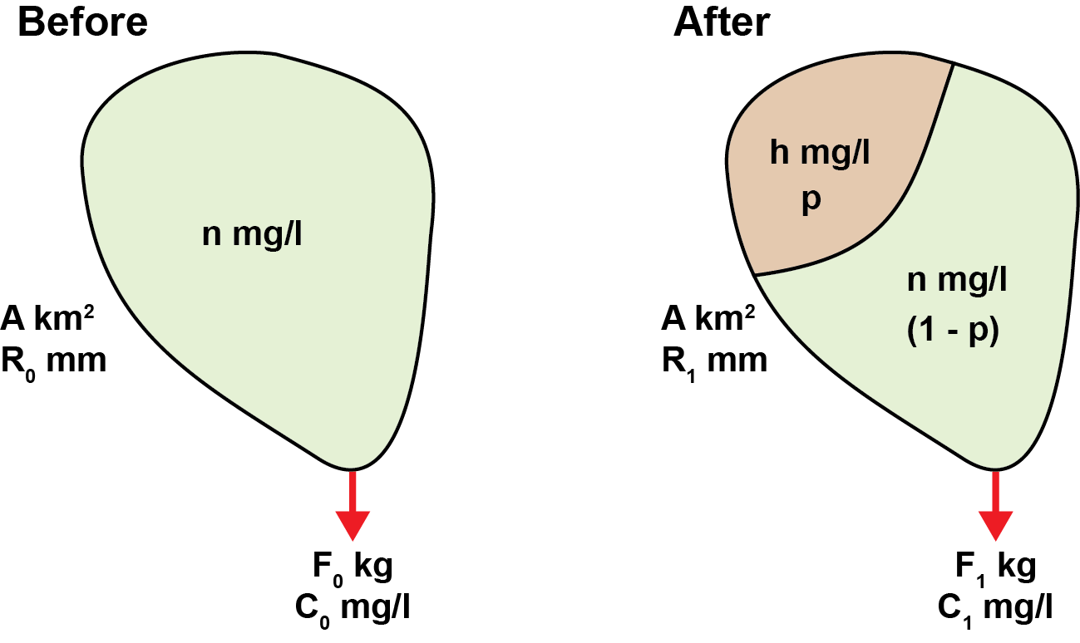

The catchment has an area of km2. Before harvesting, we assume the forest has an approximately natural mean runoff concentration of $n$ mg/l and the annual runoff is $R_{0}$ mm. A proportion $p$ of the catchment is then harvested (where $p$ is a dimensionless number between 0 and 1). The mean concentration in runoff from the harvested area changes to $h$ mg/l, while concentrations from the unharvested portion remain the same as before. The runoff in the year after harvesting is $R_{1}$ mm. Before harvesting, the flux and mean concentration measured at the catchment outflow are $F_{0}$ kg and $C_{0}$ mg/l, respectively. After harvesting, these change to $F_{1}$ kg and $C_{1}$ mg/l.

Before harvesting:

$F_{0}=AR_{0}n$ [1]

$C_{0}=n$ [2]

After harvesting:

$F_{1}=pAR_{1}h+\left(1-p\right)AR_{1}n$ [3]

$C_{1}= \frac{pAR_{1}h+\left(1-p\right)AR_{1}n}{AR_{1}}=ph+\left(1-p\right)n=ph+\left(1-p\right)C_{0}$ [4]

Rearranging [4]:

$h= \frac{C_{1}-\left(1-p\right)C_{0}}{p}$ [5]

Some studies in the literature report the change factor, $f$, of before and after concentrations measured at the catchment outflow:

$f= \frac{C_{1}}{C_{0}}$ [6]

Substituting this into equation [5] gives:

$h= \frac{C_{0}(f+p-1)}{p}$ [7]

Equations [5] and [7] make it possible to estimate typical runoff concentration from harvested forest using only basic information describing (i) before and after concentrations measured at the catchment outflow, and (ii) the proportion of the area harvested.

**2. Paired catchments, before/after study**

In addition to monitoring the change before and after harvesting in a target catchment (as described in section 1), some studies also report before/after concentrations from a nearby “reference catchment” where harvesting did not take place. This provides an additional control to allow for changes in concentration not related to the harvesting.

As an example, consider the table below:

|  |  |  |
| --- | --- | --- |
| **Catchment** | **Before concentration (mg/l)** | **After concentration (mg/l)** |
| **Reference** | 1 | 2 |
| **Target** | 2 | 6 |

In this case, concentrations doubled in the reference catchment, which implies concentrations would have also increased in the target catchment *even without harvesting*. Based on the reference, we might have expected concentrations in the target catchment to increase from 2 to 4 mg/l even if harvesting had not occurred. A simple interpretation is therefore that harvesting caused an increase from 4 to 6 mg/l (i.e. a factor of 1.5), rather than driving the full change from 2 to 6 mg/l (a factor of 3).

In this case, we can define an *effective* change factor due to harvesting, $f_{eff}$. This is analogous to the change factor in equation [6], but adjusted to represent the fact that not all changes are necessarily due to harvesting (based on changes observed in the reference catchment).

$f_{eff}= \frac{{C_{1}^{target}}/{C_{1}^{reference}}}{{C_{0}^{target}}/{C_{0}^{reference}}}$ [8]

i.e. the ratio of target to reference concentrations after harvesting divided by the ratio before harvesting. This ratio, $f_{eff}$, is often reported in the literature. Where provided, it can be used in equation [7] instead of $f$ to provide an estimate of mean concentrations from harvested land allowing for changes in a reference catchment.